SAILING INSTRUCTION (SI) GUIDE (Jan 2022)

Overview
Sailing Instructions are required by the Racing Rules of Sailing for all sailing events and must conform to RRS Appendix J2.

Important principles for the Sailing Instructions:
- Include only intentions of the race committee and obligations of the competitors
- Include only information about racing
- Do not change RRS, unless clearly desirable
- Do not repeat or rephrase the RRS or rules from other documents (NoR, Class Rules, App E, etc)
- The SIs should be in chronological order of use by competitors
- Use words or phrases from the RRS.

Unless included in the Notice of Race, the Sailing Instructions SHALL include the following:
- Schedule of races, the classes to race and the times of warning signals for each class
- Description of the course(s) to be sailed, or a list of marks from which the course will be selected and, if relevant, how courses will be signaled
- Race time limits, if any, for the first boat to finish, finishing time limit after the first boat has finished
- Unless stated in the notice of race, location(s) of official notice board(s) or address of online notice board
- Procedure for changing the sailing instructions
- Method for communicating with competitors
- Time and place of hearings, and special procedures for protests, requests for redress or requests for reopening

NOTE: The newest RRS for 2021-2024 has some significant rule number changes. Be VERY careful using SIs from prior years and carefully check rule references.

It is recommended that the Sailing Instructions be posted on AMYA in the list of regattas, on the class web site and on the local fleet web site.

<event name>
<organizing authority>
<dates>
<location>

Sailing Instructions (SIs)

- RULES
  - The event is governed by the rules as defined in The Racing Rules of Sailing and Appendix E.
  - No US Sailing Prescriptions apply except Appendix R and prescriptions to rules 60.3, 61.4, 67, 70.5(a), 76.1.
  - Add E7 (c) - If any competitor is determined to be in violation of RRS 2 - FAIR SAILING, the PRO (Principal Race Officer) may, at his discretion, without a hearing, disqualify the competitor from one or more races with DNE penalties, changing RRS 63.1 and A5.
  - Boats entering the Launch Area without race committee authorization will be penalized without a hearing, changing RRS 63.1.
  - Boats shall sail only when scheduled to race. When this instruction is broken she shall be penalized without a hearing, changing RRS 63.1.
  - Penalties for breaches of SI 1.4 and SI 1.5 shall be one or more One-Turn Penalties taken after her starting signal and before she crosses the starting line. This changes E7(b).
- COMMUNICATION WITH COMPETITORS
  - The official notice board will be at <location> or online at <URL>.
  - All communication with competitors at the event may be oral, changing E1.3(d).
- RACING AREA
  - Races will be held at <venue>. (See Attachment A).
- COURSES
  - Courses will be <announced> and/or <displayed on the course board> prior to the warning signal for the race or heat.
- THE START
  - Races will be started per E3.2(a).
  - If any part of a boat’s hull is on the course side of a starting line at her starting signal and she is identified, the race committee will attempt to hail her sail number. Failure to hail her number, failure of her to hear such a hail, or the order in which boats are hailed will not be grounds for a request for redress. This changes RRS 62.1.
  - A boat that does not start within 5 minutes after her starting sequence will be scored Did Not Start without a hearing. This changes A5.1 and A5.2.
- TIME LIMITS
  - The Race Time Limit is 30 minutes.
  - The Time Out Limit (time after the first boat finishes) is 5 minutes.
    - If more than four boats are still racing when the Time Out Limit expires, the Time Out Limit shall be extended until only four boats remain.
    - If four or fewer boats are still racing when the Time Out Limit expires, they shall be scored according to their position in the race when the Time Out Limit expired.

- HEARING REQUESTS
  - Protests and requests for redress need not be in writing, changing RRS 61.2. They shall be made orally to a member of the race committee within 5 minutes of when the last boat finishes the race/heat in which the incident occurred.
  - Protests and requests for redress will be heard immediately following the heat in which the incident occurred OR after the last race of the day using the guidance in Attachment B for expedited hearings.
- RISK STATEMENT
  - RRS 3 states: “The responsibility for a boat’s decision to participate in a race or to continue to race is hers alone.” By participating in this event each competitor agrees and acknowledges that sailing is a potentially dangerous activity with inherent risks.

Attachment A – <venue Pond>
Parking

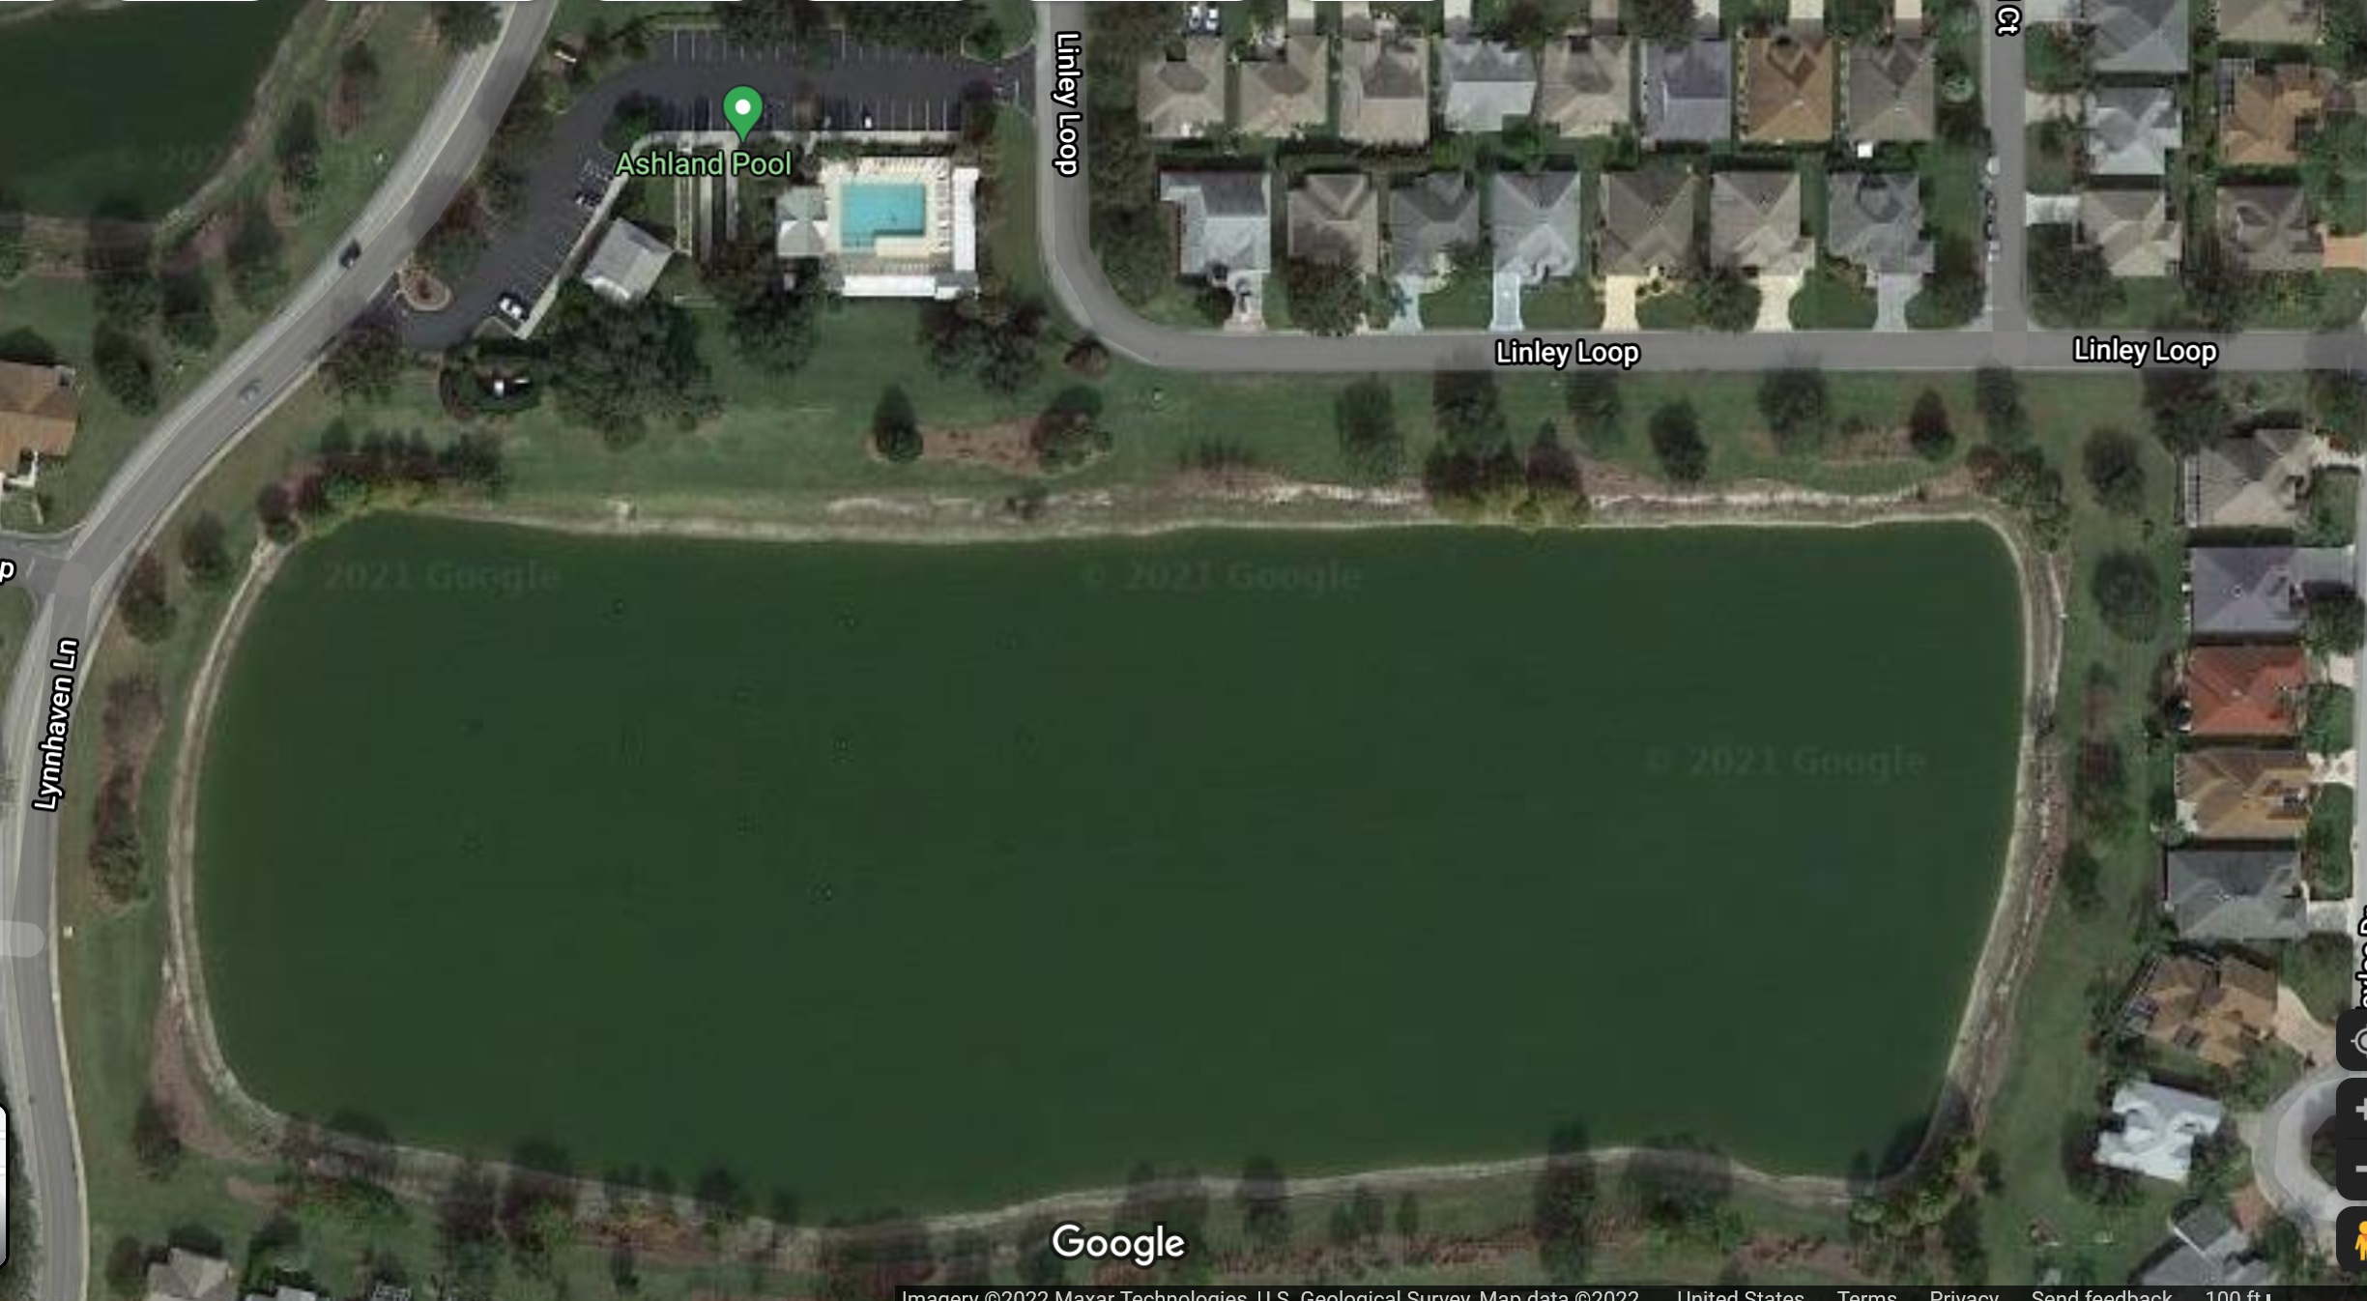
Launch Area

Control Area

NO Parking

venue Pond

Attachment B – Guidance for Expedited Hearings

  - Each party will have approximately 1 minute to state their case.
  - The judge may question the parties and call witnesses. The parties may not call witnesses but may have the witness available for the judge. This changes RRS 63.6.
  - The parties will be excused while the judge determines the facts and bases the decisions on those facts.
  - The judge will call back the parties and give them the judge’s decision.
  - The judge will inform the race committee of all decisions and will determine the penalty for a disqualified boat, which may be either a penalty as calculated as per rule 44.3(c) or as stated in RRS A5.2 or E7.

